# Exercise 3

### Question 1:

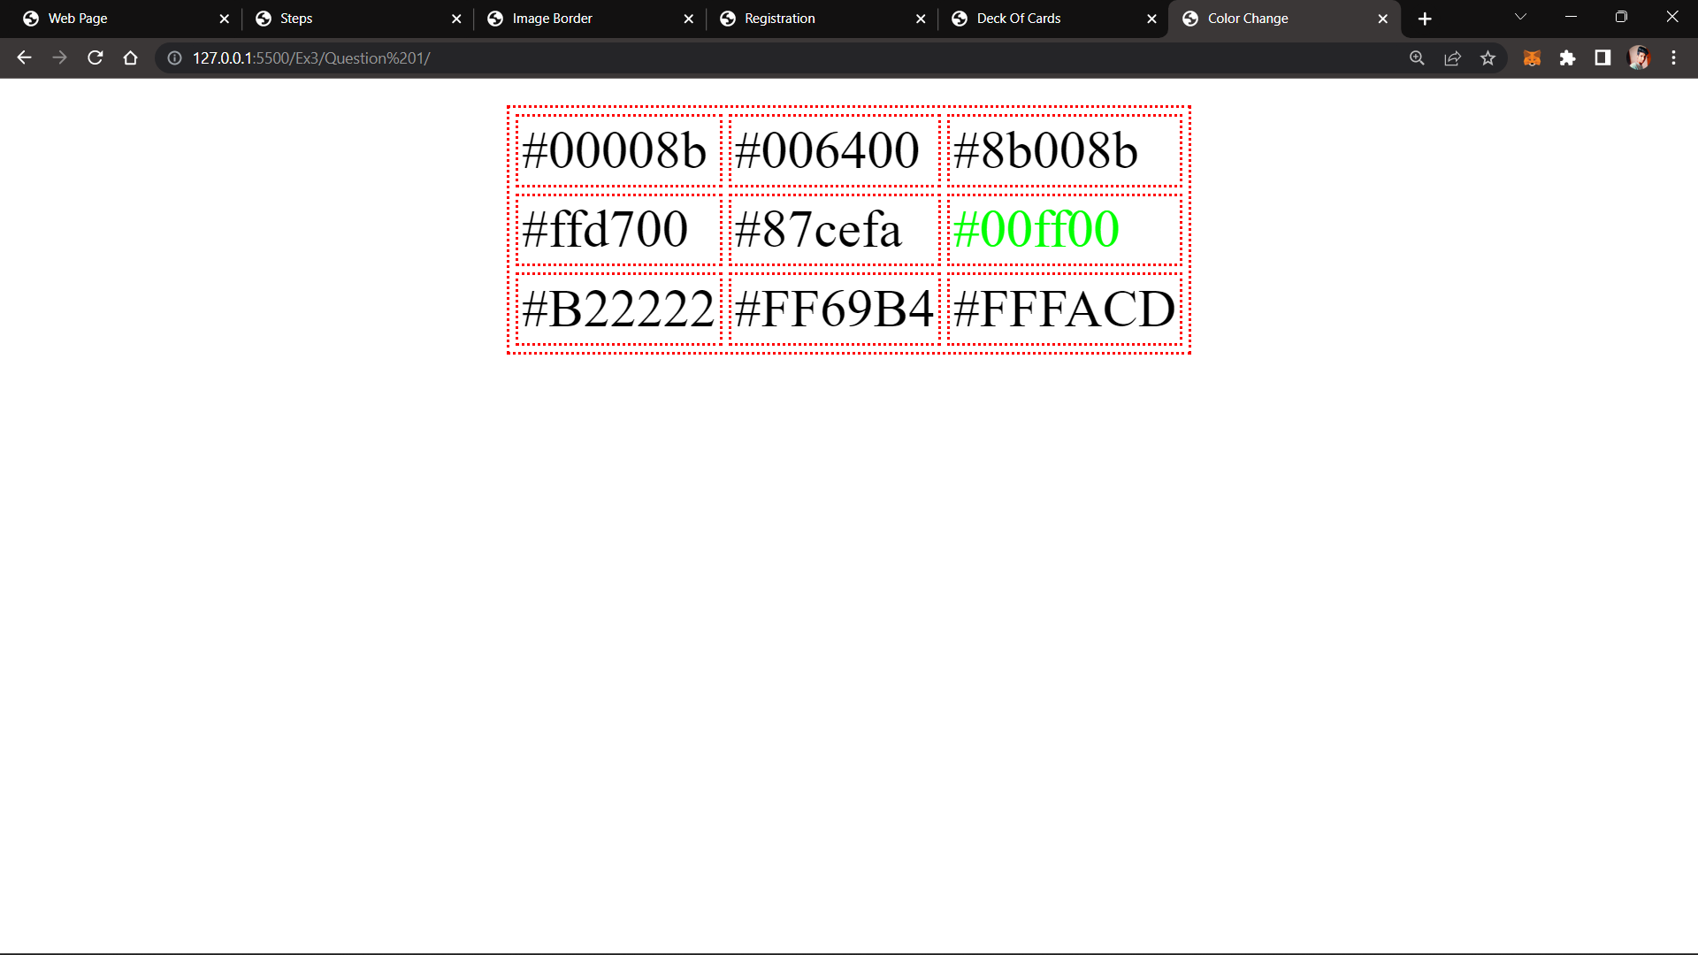

### Question 2:

### Q2

### Question 3:

### Q3

### Question 4:

